

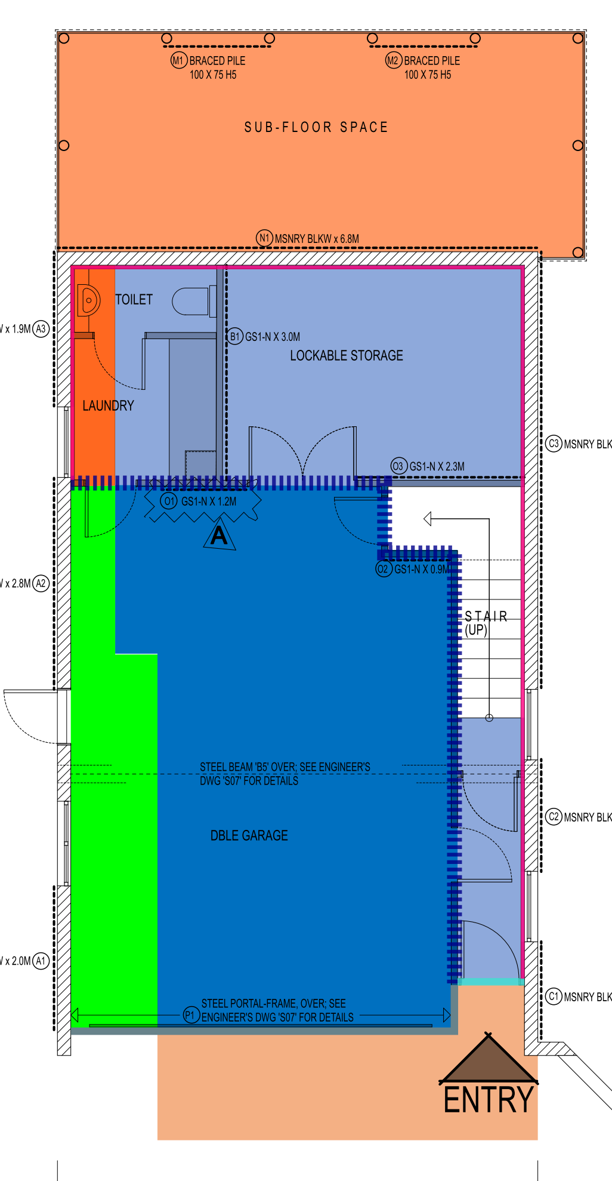**Project: 8 Ulster Road, Blockhouse Bay**

**Ground Floor:**

|  |  |
| --- | --- |
|  | **R2.4 / 90mm External Wall** |
|  | **R2.4 / 90mm Garage External Wall** |
|  | **R1.8 / 75mm G.I.W (OPTIONAL)** |
|  | **R1.3 / 50mm MASONRY WALL** |
|  | **R2.6 / 90mm UNDERFLOOR** |
|  | **R3.6 / 155mm MIDFLOOR** |
|  | **R3.6 / 155mm G.C.F.O** |
|  | **R2.6 / 90mm SOFFIT** |
|  | **R6.3 / 260mm FLAT CEILING** |
|  | **R6.3 / 260mm GARAGE FLAT CEILING** |

**First Floor:**

|  |  |
| --- | --- |
|  | **R2.4 / 90mm External Wall** |
|  | **R2.2 / 90mm Void Wall** |
|  | **R6.3 / 260mm Flat Ceiling** |
|  | **R6.0 / 240mm Raked Ceiling** |

**Sections:**

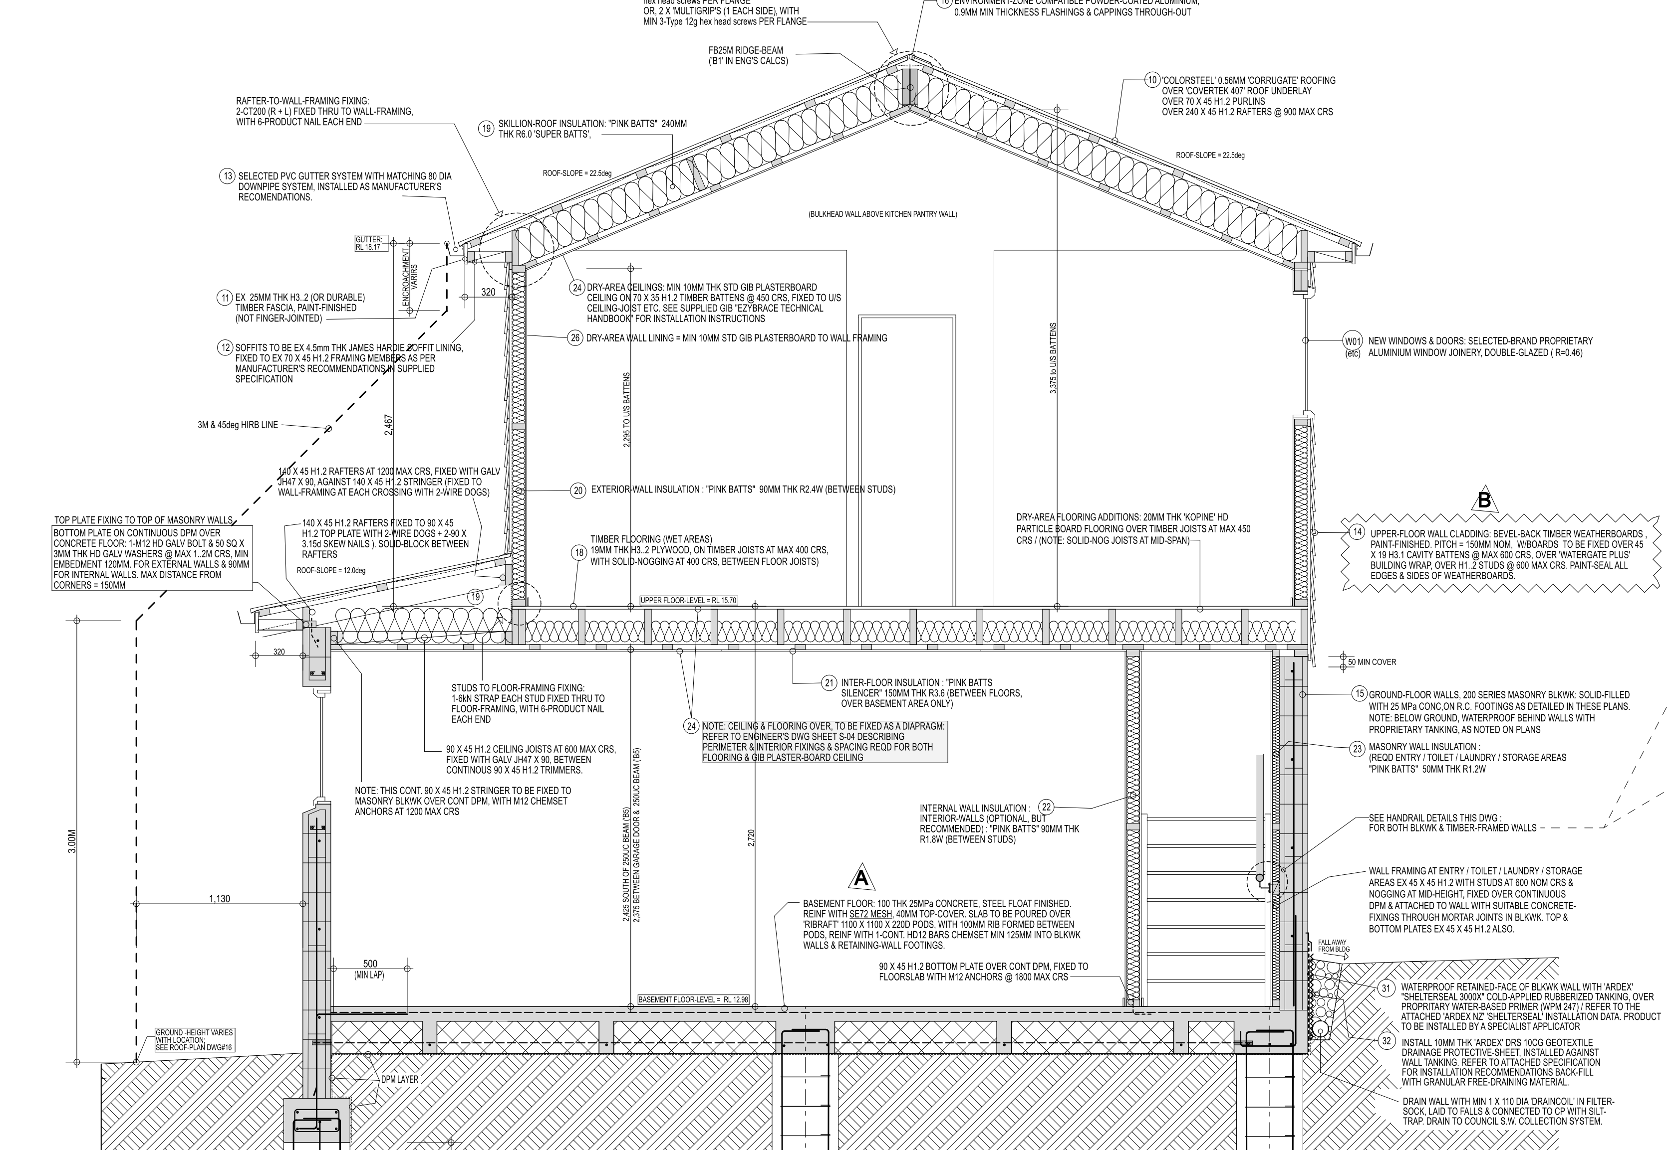

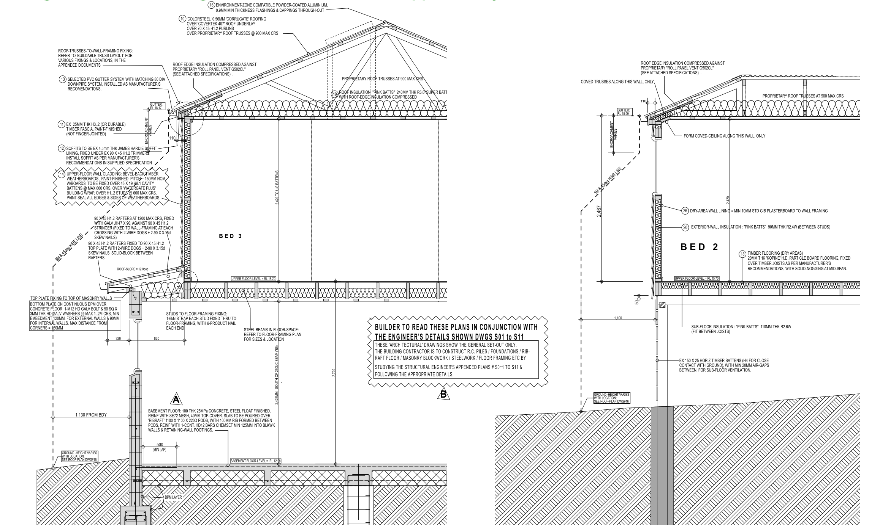

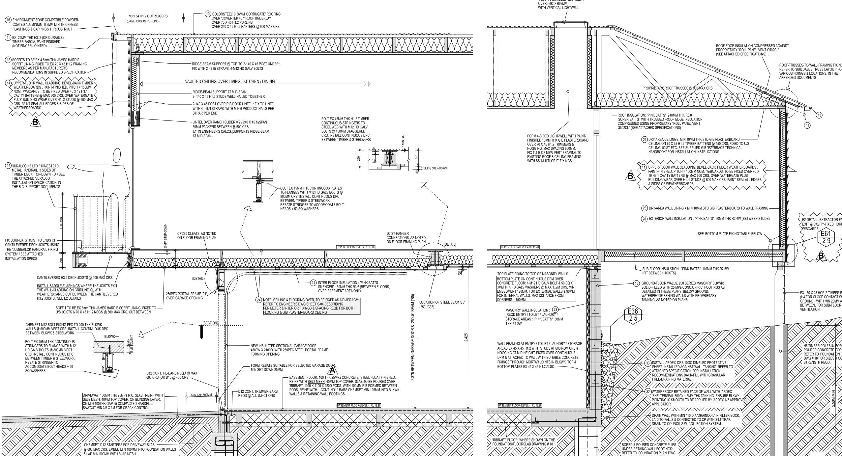

**Insulation Details:**

